LAB EXPERIMENT 7

AIM

To design and develop an Online Beauty Parlour Appointment Booking System using HTML, CSS, and JavaScript that allows customers to view beauty services, select a stylist, book appointments, manage reservations, and provide feedback. The system also enables salon administrators to manage appointments and update booking status.

PROCEDURE
- Create a project folder and create an HTML file named index.html.
- Use HTML to design the structure of the appointment booking website.
- Use CSS to style the website and make it attractive and responsive.
- Use JavaScript to display beauty services, prices, and available appointment slots.
- Create a booking form to collect customer details, services, stylist preferences, and appointment dates.
- Implement features to book, view, reschedule, and cancel appointments.
- Add an appointment history section for customers.
- Create an admin section to view appointments and update their status.
- Add a feedback form to collect customer reviews.
- Open the index.html file in a web browser and test all the features.

<!DOCTYPE html>

<html lang="en">

<head>

<meta charset="UTF-8">

<meta name="viewport" content="width=device-width,initial-scale=1.0">

<title>Beauty Parlour Appointment Booking</title>

<style>

body{font-family:Arial;margin:0;background:#fff0f5;color:#333}

header{background:#ad1457;color:white;text-align:center;padding:18px}

.container{max-width:800px;margin:20px auto;padding:20px;background:white;border-radius:10px;box-shadow:0 3px 10px #0002}

h2{color:#ad1457}

label{display:block;margin-top:10px;font-weight:bold}

input,select,textarea{width:100%;box-sizing:border-box;padding:10px;margin-top:5px}

button{padding:10px 14px;margin-top:12px;background:#ad1457;color:white;border:0;border-radius:5px;cursor:pointer}

.cancel{background:#b3261e}

.card{margin-top:12px;padding:12px;background:#fff0f5;border-radius:7px}

footer{text-align:center;padding:15px}

.note{font-size:13px;color:#666}

</style>

</head>

<body>

<header>

<h1>Beauty Parlour Appointment System</h1>

<p>Choose Services | Book Appointments | Manage Reservations</p>

</header>

<div class="container">

<h2>1. Beauty Services</h2>

<div class="card">

<p>Haircut - ₹300</p>

<p>Facial - ₹800</p>

<p>Hair Styling - ₹500</p>

<p>Manicure - ₹400</p>

<p>Makeup - ₹1500</p>

</div>

<h2>2. Book Appointment</h2>

<label>Customer Name</label>

<input id="name" placeholder="Enter your name">

<label>Phone Number</label>

<input id="phone" type="tel" placeholder="Enter phone number">

<label>Select Service</label>

<select id="service">

<option value="Haircut">Haircut - ₹300</option>

<option value="Facial">Facial - ₹800</option>

<option value="Hair Styling">Hair Styling - ₹500</option>

<option value="Manicure">Manicure - ₹400</option>

<option value="Makeup">Makeup - ₹1500</option>

</select>

<label>Select Stylist</label>

<select id="stylist">

<option>Priya</option>

<option>Anitha</option>

<option>Divya</option>

</select>

<label>Appointment Date</label>

<input id="date" type="date">

<label>Appointment Time</label>

<select id="time">

<option value="10:00 AM">10:00 AM</option>

<option value="11:00 AM">11:00 AM</option>

<option value="12:00 PM">12:00 PM</option>

<option value="02:00 PM">02:00 PM</option>

<option value="03:00 PM">03:00 PM</option>

<option value="04:00 PM">04:00 PM</option>

</select>

<button onclick="bookAppointment()">Book Appointment</button>

<div id="message"></div>

<hr>

<h2>3. My Appointments</h2>

<div id="appointments">No appointments yet.</div>

<hr>

<h2>4. Admin Panel</h2>

<button onclick="showAdmin()">View All Appointments</button>

<div id="admin"></div>

<hr>

<h2>5. Customer Feedback</h2>

<label>Your Feedback</label>

<textarea id="feedback" placeholder="Write your feedback"></textarea>

<button onclick="sendFeedback()">Submit Feedback</button>

<div id="feedbackMessage"></div>

<p class="note">Lab demonstration only. Appointments are stored temporarily in the browser. Real payments, SMS, email reminders, and database connectivity are not included.</p>

</div>

<footer>Online Beauty Parlour Appointment Booking System</footer>

<script>

const appointments=[];

const prices={"Haircut":300,"Facial":800,"Hair Styling":500,"Manicure":400,"Makeup":1500};

function bookAppointment(){

const name=document.getElementById("name").value.trim();

const phone=document.getElementById("phone").value.trim();

const service=document.getElementById("service").value;

const stylist=document.getElementById("stylist").value;

const date=document.getElementById("date").value;

const time=document.getElementById("time").value;

if(!name||!phone||!date){alert("Please fill in all required details.");return}

if(!/^[0-9]{10}$/.test(phone)){alert("Enter a valid 10-digit phone number.");return}

if(date<new Date().toLocaleDateString("en-CA")){alert("Select today or a future date.");return}

if(appointments.some(a=>a.date===date&&a.time===time&&a.stylist===stylist&&a.status==="Booked")){alert("This stylist's time slot is already booked.");return}

const appointment={id:"SAL"+Math.floor(10000+Math.random()*90000),name,phone,service,stylist,date,time,price:prices[service],status:"Booked"};

appointments.push(appointment);

document.getElementById("message").innerHTML=`<div class="card"><h3>Appointment Booked!</h3><p>Booking ID: ${appointment.id}</p><p>Service: ${service}</p><p>Stylist: ${stylist}</p><p>Date: ${date}</p><p>Time: ${time}</p><p>Price: ₹${appointment.price}</p></div>`;

showAppointments();

}

function showAppointments(){

const box=document.getElementById("appointments");

if(!appointments.length){box.textContent="No appointments yet.";return}

box.innerHTML=appointments.map(a=>`<div class="card"><b>ID:</b> ${a.id}<br><b>Customer:</b> ${a.name}<br><b>Service:</b> ${a.service}<br><b>Stylist:</b> ${a.stylist}<br><b>Date:</b> ${a.date}<br><b>Time:</b> ${a.time}<br><b>Status:</b> ${a.status}<br><button class="cancel" onclick="cancelAppointment('${a.id}')">Cancel Appointment</button></div>`).join("");

}

function cancelAppointment(id){

const a=appointments.find(x=>x.id===id);

if(a&&a.status==="Booked"){a.status="Cancelled";showAppointments()}

}

function showAdmin(){

const box=document.getElementById("admin");

if(!appointments.length){box.textContent="No appointments available.";return}

box.innerHTML=appointments.map(a=>`<div class="card"><p>${a.id} - ${a.name}</p><p>${a.service} | ${a.date} | ${a.time}</p><p>Status: ${a.status}</p></div>`).join("");

}

function sendFeedback(){

const feedback=document.getElementById("feedback").value.trim();

if(!feedback){alert("Please enter your feedback.");return}

document.getElementById("feedbackMessage").innerHTML='<div class="card">Thank you for your feedback!</div>';

document.getElementById("feedback").value="";

}

</script>

</body>

</html>

IMPLEMENTATION
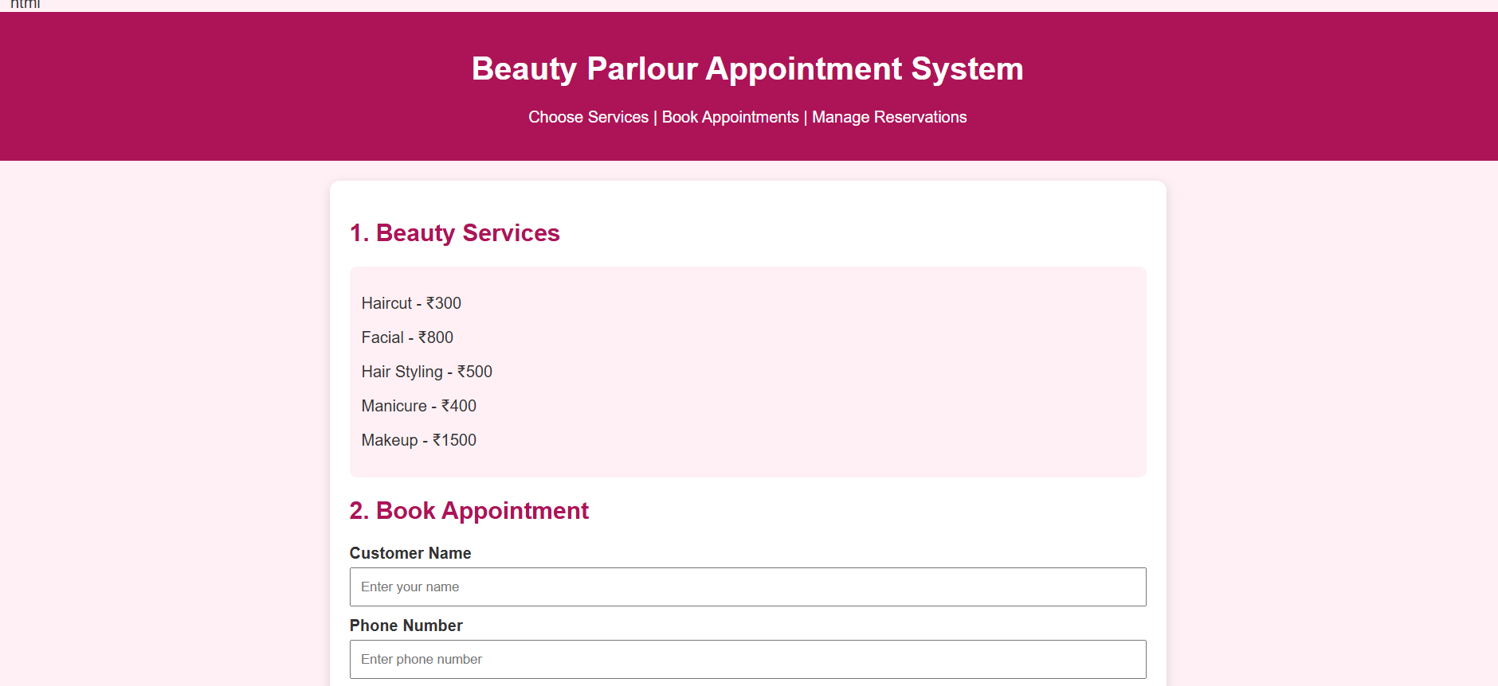
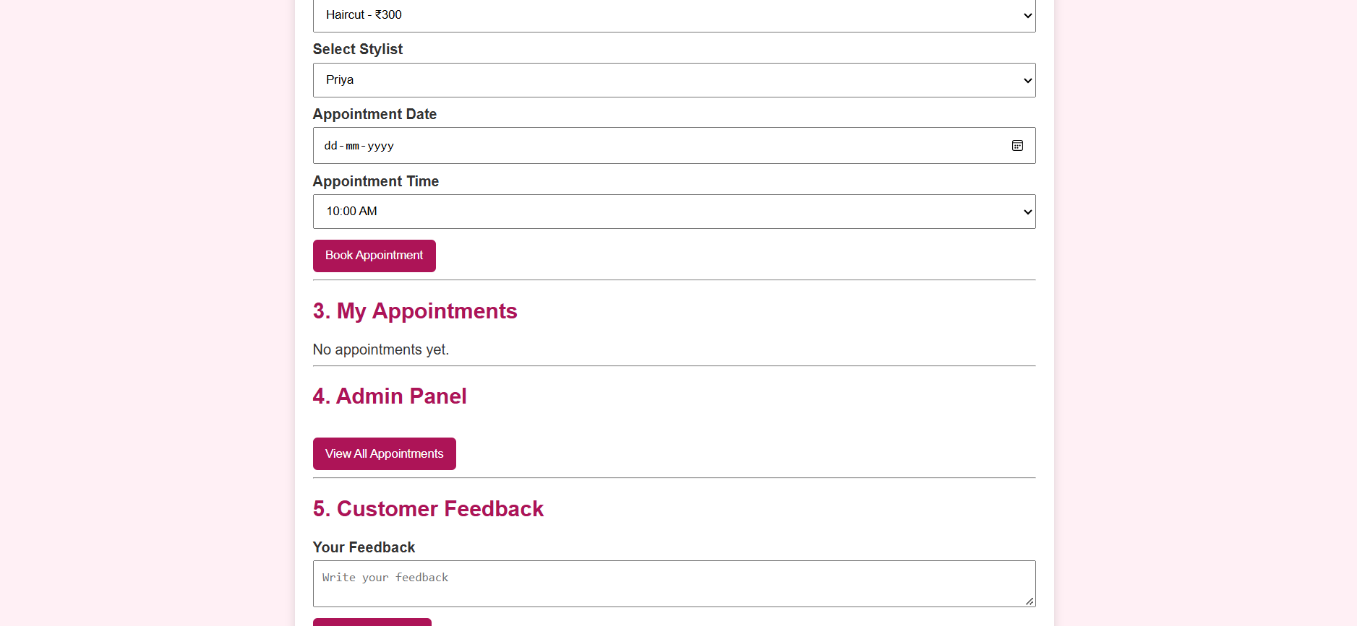

RESULT
Thus, the Online Beauty Parlour Appointment Booking System was successfully designed and implemented using HTML, CSS, and JavaScript. The system allows customers to view services, select a stylist, book and cancel appointments, view appointment details, and submit feedback. The admin panel enables the management and viewing of customer reservations through a user-friendly interface.

